Project Overview
AI Transcript Evaluator

Purpose
The AI Transcript Evaluator is a hybrid evaluation system designed to assess spoken communication from video recordings.
The system accepts a video as input, converts speech into text using OpenAI Whisper, evaluates the resulting transcript using a combination of local NLP techniques and Large Language Models, and presents detailed feedback through a Streamlit-based dashboard.
The evaluation focuses on five categories:
- Grammar
- Vocabulary
- Clarity
- Technical Accuracy
- Professionalism
The primary objective of the project was to explore practical applications of speech recognition, natural language processing, and AI-assisted evaluation while maintaining a balance between scalability, explainability, and token efficiency.

Project Outcome
The final system successfully:
- Transcribes uploaded videos into text.
- Evaluates grammar using LanguageTool.
- Measures vocabulary richness using MTLD.
- Uses Gemini to evaluate clarity, technical accuracy, and professionalism.
- Generates category-wise scores and feedback.
- Displays results through an interactive Streamlit interface.
- Runs successfully on multiple machines after dependency setup.

2. Problem Statement.
Evaluating spoken responses manually is time-consuming and subjective.
The goal of this project was to automate transcript evaluation while providing meaningful feedback across multiple communication dimensions.

Motivation
Spoken communication plays an important role in interviews, presentations, technical discussions, and educational assessments. Evaluating communication quality manually requires significant time and effort and may vary depending on the evaluator.
Many existing approaches either rely entirely on human evaluation or use Large Language Models for every assessment task. While LLM-based systems can provide detailed feedback, they may increase operational costs and token consumption when objective metrics are repeatedly evaluated.

Problem Definition
The objective of this project was to develop an automated transcript evaluation system capable of analyzing spoken responses from video recordings and generating meaningful feedback across multiple communication dimensions.

The system should:
- Accept a video recording as input.
- Convert speech into text automatically.
- Evaluate grammar quality.
- Measure vocabulary richness.
- Assess clarity of communication.
- Evaluate technical accuracy.
- Measure professionalism of language.
- Present results through an intuitive user interface.

Project Goals
The project was designed with the following goals:
- Automate transcript evaluation.
- Reduce dependence on manual assessment.
- Minimize unnecessary LLM usage.
- Maintain explainability for objective metrics.
- Provide useful and actionable feedback.
- Create a scalable architecture suitable for future expansion.

Success Criteria
The project would be considered successful if it could:
- Generate accurate transcripts from uploaded videos.
- Produce meaningful scores across all evaluation categories.
- Display results through a user-friendly dashboard.
- Balance evaluation quality with efficient API usage.
- Operate consistently across different environments after deployment.

3. System Architecture
Overview
The AI Transcript Evaluator follows a hybrid evaluation architecture that combines local Natural Language Processing techniques with Large Language Model-based assessment.
The system processes an uploaded video through multiple stages, beginning with speech transcription and ending with a detailed evaluation report.
The architecture was designed to balance evaluation quality, scalability, and token efficiency.
Workflow
- The user uploads a video file.
- OpenAI Whisper converts speech into text.
- The transcript is passed to multiple evaluation modules.
- Grammar and vocabulary are evaluated locally.
- Clarity, technical accuracy, and professionalism are evaluated using Gemini.
- All scores are aggregated into a final report.
- Results are displayed through the Streamlit dashboard.
Architecture Diagram
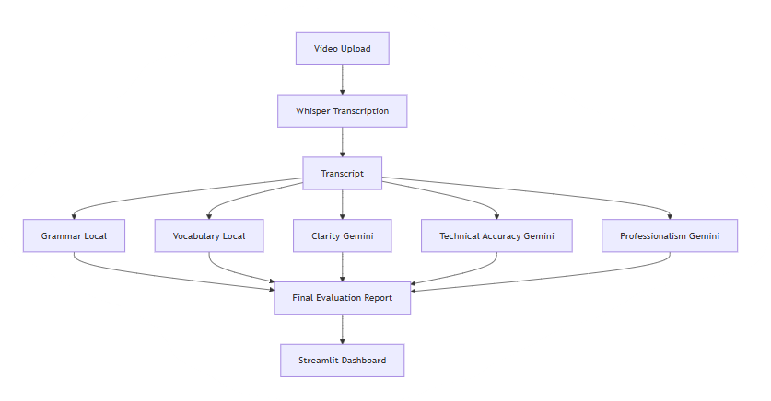
Component Description
Speech-to-Text Layer
OpenAI Whisper is responsible for converting spoken content into text. This transcription serves as the foundation for all subsequent evaluations.

Local Evaluation Layer
The local evaluation layer performs objective assessments that do not require advanced reasoning.
This layer includes:
- Grammar Evaluation
- Vocabulary Evaluation
These metrics are calculated locally without using external AI services.

AI Evaluation Layer
The AI evaluation layer uses Google's Gemini model to assess communication characteristics that require contextual understanding and reasoning.
This layer includes:
- Clarity
- Technical Accuracy
- Professionalism
These categories are more subjective and therefore benefit from LLM-based analysis.

Presentation Layer
The Streamlit frontend presents:
- Individual category scores
- Overall score
- Radar chart visualization
- Detailed feedback
- Transcript viewer
This allows users to easily understand strengths and areas for improvement.

Architectural Advantages
The hybrid architecture provides several benefits:
- Reduced token consumption
- Lower operational costs
- Improved scalability
- Better explainability
- Clear separation between objective and subjective evaluation tasks
By assigning objective metrics to local computation and subjective metrics to Gemini, the system avoids unnecessary AI usage while preserving evaluation quality.

4. Design Decisions
Overview
Throughout the development process, multiple approaches were considered for transcript evaluation. Several alternatives were evaluated and rejected based on scalability, fairness, explainability, and operational efficiency.
This chapter documents the reasoning behind the final design choices.

Hybrid Evaluation Architecture
Initial Idea
The initial concept was to use a Large Language Model to evaluate every assessment category.
This approach would allow a single model to generate all evaluation scores and feedback.

Problem
A fully LLM-based system would require every evaluation category to consume tokens.
This introduces several challenges:
- Increased API usage
- Higher operational cost
- Reduced scalability
- Unnecessary use of AI for objective metrics

Final Decision
A hybrid architecture was adopted.
Local Evaluation:
- Grammar
- Vocabulary
Gemini Evaluation:
- Clarity
- Technical Accuracy
- Professionalism
Grammar and vocabulary can be measured using deterministic methods without requiring advanced reasoning.
Clarity, technical accuracy, and professionalism involve contextual understanding and therefore benefit from LLM-based evaluation.
This separation significantly reduces token consumption while maintaining evaluation quality.

Grammar Evaluation Strategy -- Rejected Approach

Absolute grammar error count.
Example:
Transcript A:
100 words
5 errors
Transcript B:
500 words
5 errors
Both transcripts would receive the same penalty despite having different error densities.

Problem
Longer transcripts naturally accumulate more errors.
Using absolute counts unfairly penalizes users who provide longer responses.

Final Decision
Use normalized grammar error density.
Grammar quality is measured relative to transcript length rather than total error count.
This creates a fairer evaluation system and allows transcripts of different lengths to be compared consistently.

Vocabulary Evaluation Strategy--Rejected Approach

Type Token Ratio (TTR).

Problem
TTR decreases as transcript length increases.
This introduces significant transcript-length bias.

Alternative Considered
Root Type Token Ratio (RTTR).
While more stable than TTR, some length sensitivity still remains.

Final Decision
Measure vocabulary richness using MTLD (Measure of Textual Lexical Diversity).
MTLD remains relatively stable across varying transcript lengths and is commonly used in lexical diversity research.
This makes it more suitable for transcript evaluation.

Professionalism Evaluation Strategy -- Rejected Approach

Rule-based scoring using predefined keyword lists.

Problem
Professional language depends heavily on context.
A sentence may appear informal or professional depending on how it is used.
Keyword-based approaches cannot reliably capture these nuances.

Final Decision
Evaluate professionalism using Gemini.

Reasoning
Professionalism requires contextual interpretation, making it more suitable for LLM-based evaluation.

Clarity Evaluation Strategy -- Rejected Approach

Rule-based readability metrics.

Problem
Readability formulas do not necessarily reflect communication effectiveness.
A grammatically correct response can still be confusing or poorly structured.

Final Decision
Use Gemini to evaluate clarity.

Reasoning
Clarity involves coherence, organization, and logical flow, which are better assessed through contextual reasoning.

Scalability Considerations
One of the primary goals of the project was to avoid unnecessary token usage.
Consider a scenario involving a large number of transcript submissions.
A fully LLM-based architecture would require every evaluation category to consume tokens.
By evaluating objective metrics locally, only the categories requiring contextual reasoning are sent to Gemini.
This significantly improves scalability while preserving evaluation quality.
Summary
The final architecture was selected because it provides:
- Fairer scoring
- Reduced token consumption
- Better scalability
- Improved explainability
- Clear separation between objective and subjective evaluation tasks
These decisions collectively resulted in a balanced and efficient transcript evaluation system.

5. Implementation Details
Overview
The AI Transcript Evaluator was implemented as a modular system consisting of separate components responsible for transcription, evaluation, visualization, and user interaction.
The project was developed in Python and integrated multiple open-source tools and APIs to perform transcript analysis.

Technology Stack
Component | Technology
Frontend | Streamlit
Speech-to-Text | OpenAI Whisper
Grammar Evaluation | LanguageTool
Vocabulary Evaluation | LexicalRichness (MTLD)
AI Evaluation | Google Gemini
Visualization | Matplotlib
Version Control | Git & GitHub

Frontend Implementation
The user interface was developed using Streamlit.
Responsibilities:
- Video upload interface
- Evaluation result display
- Score visualization
- Radar chart generation
- Transcript viewing
The dashboard was designed to provide an intuitive overview of transcript quality while maintaining a clean and simple user experience.

Speech Transcription Module
The transcription module uses OpenAI Whisper.
Workflow:
- User uploads a video.
- Audio is extracted using FFmpeg.
- Whisper transcribes the speech.
- Transcript is returned for further analysis.
This transcript acts as the primary input for all evaluation modules.

Grammar Evaluation Module
Grammar evaluation is performed using LanguageTool.
Implementation Steps:
- Receive transcript.
- Detect grammatical errors.
- Count identified issues.
- Compute error density relative to transcript length.
- Convert error density into a normalized score.
This approach ensures fairness across transcripts of different lengths.
Vocabulary Evaluation Module
Vocabulary richness is evaluated using MTLD.
Implementation Steps:
- Receive transcript.
- Calculate MTLD score.
- Normalize MTLD values into a 0–10 scale.
- Return vocabulary score.
MTLD was selected due to its stability across varying transcript lengths.

Gemini Evaluation Module
Gemini is responsible for evaluating:
- Clarity
- Technical Accuracy
- Professionalism
Implementation Steps:
- Receive transcript.
- Send transcript to Gemini.
- Request structured evaluation.
- Extract scores and reasoning.
- Return results to the main application.
This module handles subjective assessments that require contextual understanding.

Visualization Module
Matplotlib is used to generate radar chart visualizations.
The radar chart displays:
- Grammar
- Vocabulary
- Clarity
- Technical Accuracy
- Professionalism
This allows users to quickly identify strengths and weaknesses across evaluation categories.

Result Aggregation
After all evaluation modules complete execution:
- Individual scores are collected.
- Overall score is calculated.
- Feedback is assembled.
- Visualizations are generated.
- Results are displayed through the dashboard.
The final output includes:
- Overall Score
- Category Scores
- Radar Chart
- Feedback
- Transcript Viewer

Repository Structure
AI-Transcript-Evaluator/
│
├── streamlit_app.py
├── backend.py
├── evaluator.py
├── grammar.py
├── vocabulary.py
├── requirements.txt
├── README.md
└── .env
The modular structure was chosen to separate responsibilities and improve maintainability.
6. Challenges Encountered
Overview
During development, several technical and deployment-related challenges were encountered. These challenges influenced both the final architecture and the deployment process of the application.
Documenting these issues provides insight into the practical considerations involved in building and deploying AI-powered applications.

Challenge 1: Balancing Local Evaluation and LLM Usage
Problem
An early design consideration was whether all evaluation metrics should be handled by Gemini.
While this approach would simplify implementation, it would also require every evaluation category to consume API requests and tokens.
Impact
- Increased API dependency
- Higher token consumption
- Reduced scalability
- Increased operational costs
Resolution
A hybrid architecture was adopted.
Objective metrics:
- Grammar
- Vocabulary
were evaluated locally.
Subjective metrics:
- Clarity
- Technical Accuracy
- Professionalism
remained LLM-based.
This significantly reduced unnecessary API usage.

Challenge 2: Gemini API Quotas
Problem
During testing, free-tier Gemini limits occasionally restricted the number of transcript evaluations that could be performed within a given period. Gemini API key provides around 1 Million tokens for input and around 65 thousand for output
Gemini API free tier includes only 15 uploads ( prompts ) per minute across API key in the same project
Impact
- Interrupted testing sessions
- Reduced development efficiency
- Highlighted scalability concerns
Resolution
The architecture was designed to minimize LLM calls by evaluating objective metrics locally and reserving Gemini only for tasks requiring contextual reasoning.

Challenge 3: Grammar Evaluation Fairness
Problem
An initial approach considered using absolute grammar error counts.
However, longer transcripts naturally accumulate more errors than shorter transcripts.
Impact
Users providing longer responses could be unfairly penalized despite demonstrating better communication quality.
Resolution
Grammar quality was measured using normalized error density rather than raw error counts.
This allowed transcripts of varying lengths to be evaluated more fairly.

Challenge 4: Vocabulary Evaluation Bias
Problem
Traditional lexical diversity measures such as Type Token Ratio (TTR) are highly sensitive to transcript length.

Impact
Longer transcripts could receive lower vocabulary scores even when vocabulary quality remained strong.
Resolution
MTLD was selected as the vocabulary metric because it remains more stable across varying transcript lengths.

Challenge 5: Dependency Management
Problem
The project relied on multiple technologies beyond standard Python packages.
Additional requirements included:
- Java
- FFmpeg
- Gemini API credentials
Impact
The application could fail even when all Python dependencies were installed correctly.
Resolution
System-level dependencies were documented and installation instructions were updated.

Challenge 6: Cross-Machine Deployment
Problem
The application initially worked only on the primary development machine.
When tested on a second computer, several hidden assumptions became visible.
Issues Identified
- Java not installed
- FFmpeg not installed
- Missing environment variables
- API key configuration issues
Resolution
Each issue was identified and resolved through systematic testing.
The setup process was documented to improve reproducibility.

Challenge 7: Environment Configuration
Problem
The Gemini API key was stored using environment variables and was intentionally excluded from version control.
When the repository was cloned to another machine, the application failed because the required environment variables were not configured.
Resolution
A dedicated .env configuration process was documented and verified during deployment testing.
Summary
The challenges encountered during development highlighted the importance of:
- Scalable architecture design
- Fair evaluation metrics
- Dependency management
- Deployment testing
- Environment configuration
Resolving these issues improved both the robustness and maintainability of the final system.

8.Future Improvements
- Local LLM integration
- Batch transcript evaluation
- PDF report generation
- Historical performance tracking
- User authentication
- Cloud deployment
- Advanced analytics dashboard

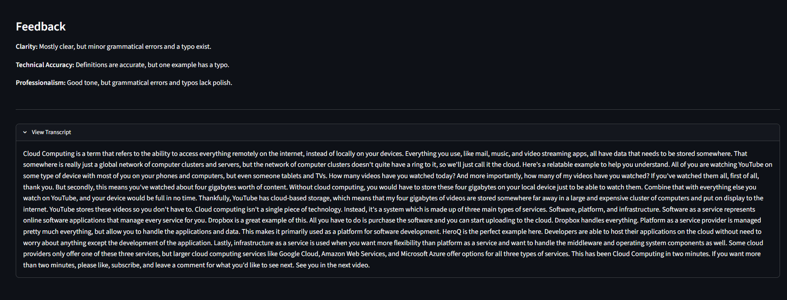
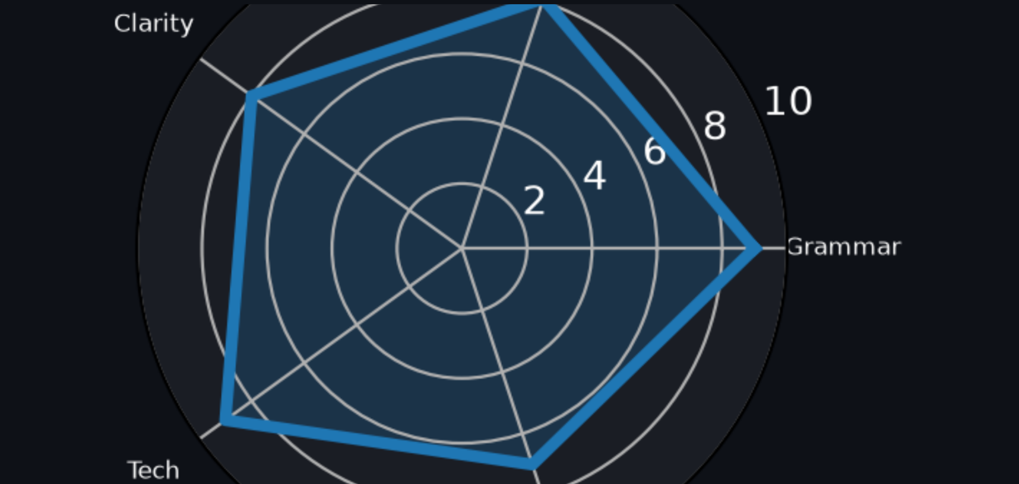
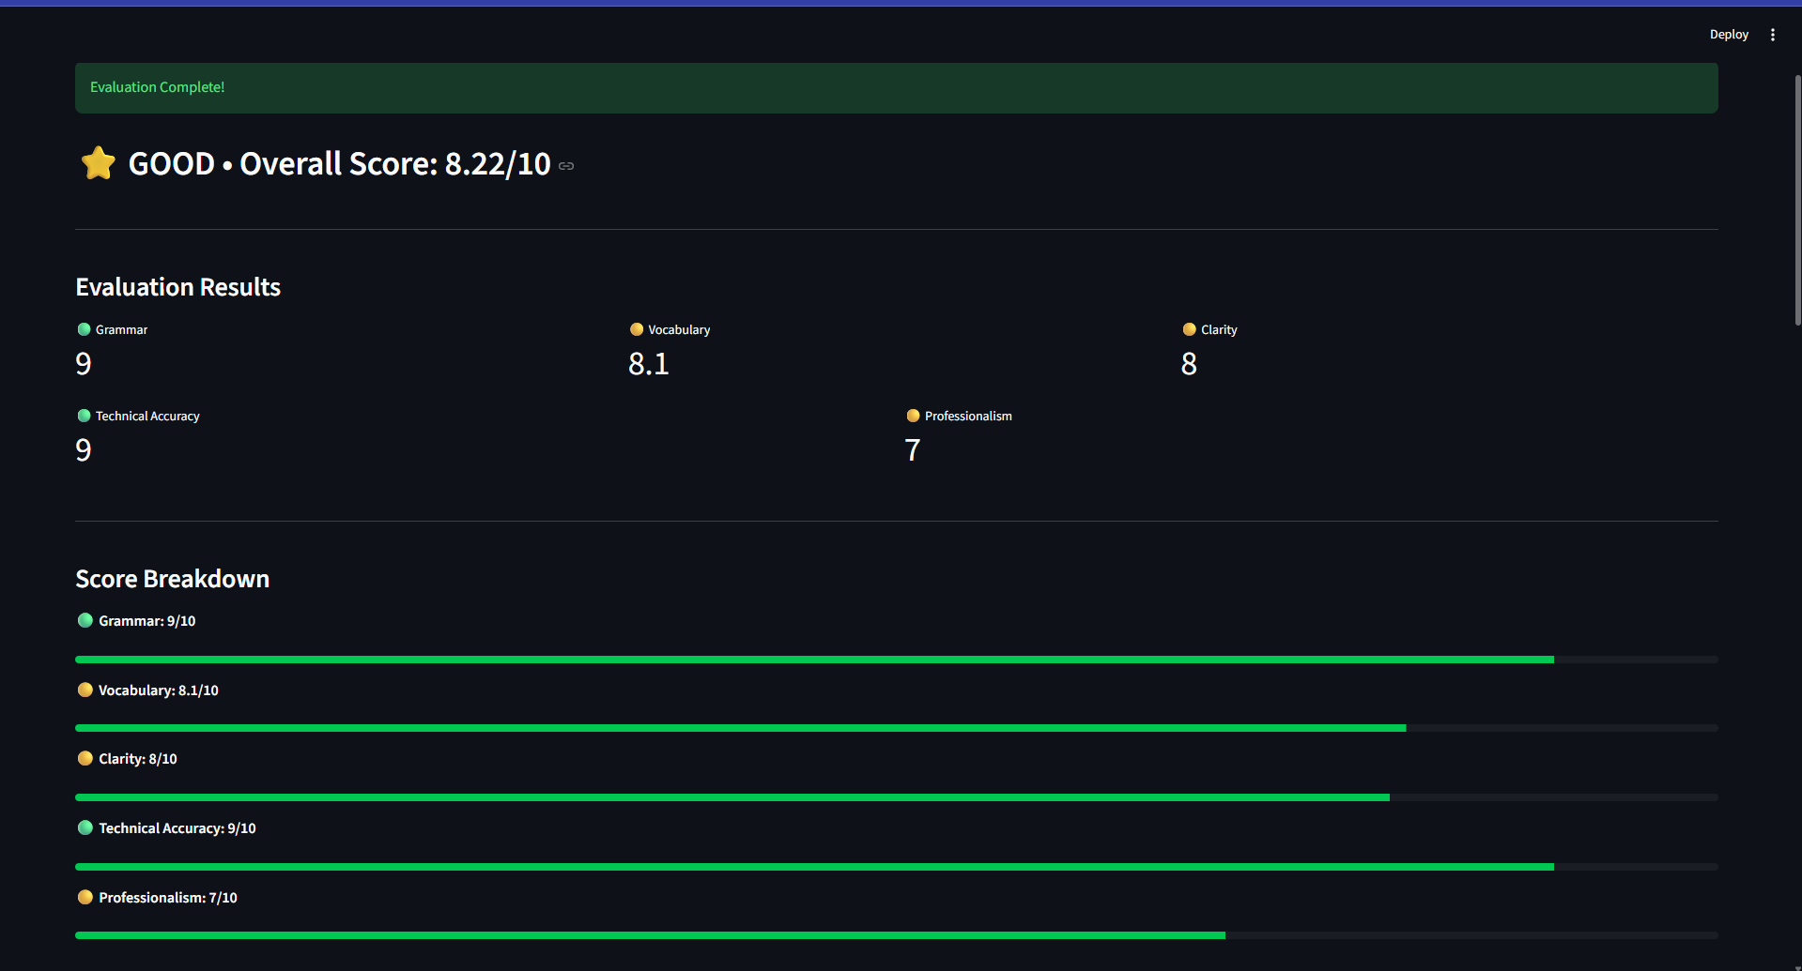
OUTPUT

